
Individual Assessment Coversheet
To be attached to the front of the assessment.
Campus: Midrand_______________________________________________________
Faculty: Information Technology__________________________________________
Module Code: ITPNA_________________________________________________________
Group: 1______________________________________________________________
Lecturer’s Name: Mr Rametse ___________________________________________________
Student Full Name: Asimdumise Zwane______________________________________________
Student Number: Eduv4935855___________________________________________________

Indicate | Yes | No
Plagiarism report attached

Declaration:
I declare that this assessment is my own original work except for source material explicitly acknowledged. I also declare that this assessment or any other of my original work related to it has not been previously, or is not being simultaneously, submitted for this or any other course. I am aware of the AI policy and acknowledge that I have not used any AI technology to generate or manipulate data, other than as permitted by the assessment instructions. I also declare that I am aware of the Institution’s policy and regulations on honesty in academic work as set out in the Conditions of Enrolment, and of the disciplinary guidelines applicable to breaches of such policy and regulations.

Signature | Date: 17/03/2025

Lecturer’s Comments:

Marks Awarded: |  | %
Signature | Date

Eduvos (Pty) Ltd. (formerly Pearson Institute of Higher Education) is registered with the Department of Higher Education and Training as a private higher education institution under the Higher Education Act, 101, of 1997. Registration Certificate number: 2001/HE07/008

Table of Contents
Question 1 1
Question 2 6
Question 3 13
Question 4 17
Works Cited 19

Figure 1 Proof of tls transfer server 3
Figure 2 Proof of Client implementation 4
Figure 3 Server that requires mutual authentication 6
Figure 4 Fastest DNS Server 8
Figure 5 Dns resolution system 9
Figure 6 load-balancing mechanism 10
Figure 7 dns-over-https resolution 11
Figure 8 dns query caching 13
Figure 9 Tcp server using multithreading 15
Figure 10 tcp client 18
Figure 11 UDP Server 19
Figure 12 Dns client 20

Question 1

1.1.
import socket
import ssl
import os

# Server configuration
HOST = '0.0.0.0' # Listen on all available network interfaces
PORT = 8443 # Secure port
CERT_FILE = "certificate.pem"
KEY_FILE = "private.key"
SAVE_DIR = "received_files"

# Ensure save directory exists
os.makedirs(SAVE_DIR, exist_ok=True)

def handle_client(conn):
""" Handles incoming file transfer from the client """
try:
# Receive file name length and name
file_name_len = int.from_bytes(conn.recv(2), 'big')
file_name = conn.recv(file_name_len).decode()

# Receive file size
file_size = int.from_bytes(conn.recv(8), 'big')

# Save file
file_path = os.path.join(SAVE_DIR, file_name)
with open(file_path, 'wb') as f:
received = 0
while received < file_size:
chunk = conn.recv(min(4096, file_size - received))
if not chunk:
break
f.write(chunk)
received += len(chunk)

print(f"File '{file_name}' received successfully.")
except Exception as e:
print(f"Error during file transfer: {e}")
finally:
conn.close()

def start_tls_server():
""" Starts the TLS server for secure file transfers """
context = ssl.create_default_context(ssl.Purpose.CLIENT_AUTH)
context.load_cert_chain(certfile=CERT_FILE, keyfile=KEY_FILE)

with socket.socket(socket.AF_INET, socket.SOCK_STREAM) as server_socket:
server_socket.bind((HOST, PORT))
server_socket.listen(5)
print(f"[*] Secure file transfer server listening on {HOST}:{PORT}...")

while True:
client_socket, addr = server_socket.accept()
print(f"[+] Connection from {addr}")
with context.wrap_socket(client_socket, server_side=True) as tls_conn:
handle_client(tls_conn)

if "_name_" == "_main_":
start_tls_server()

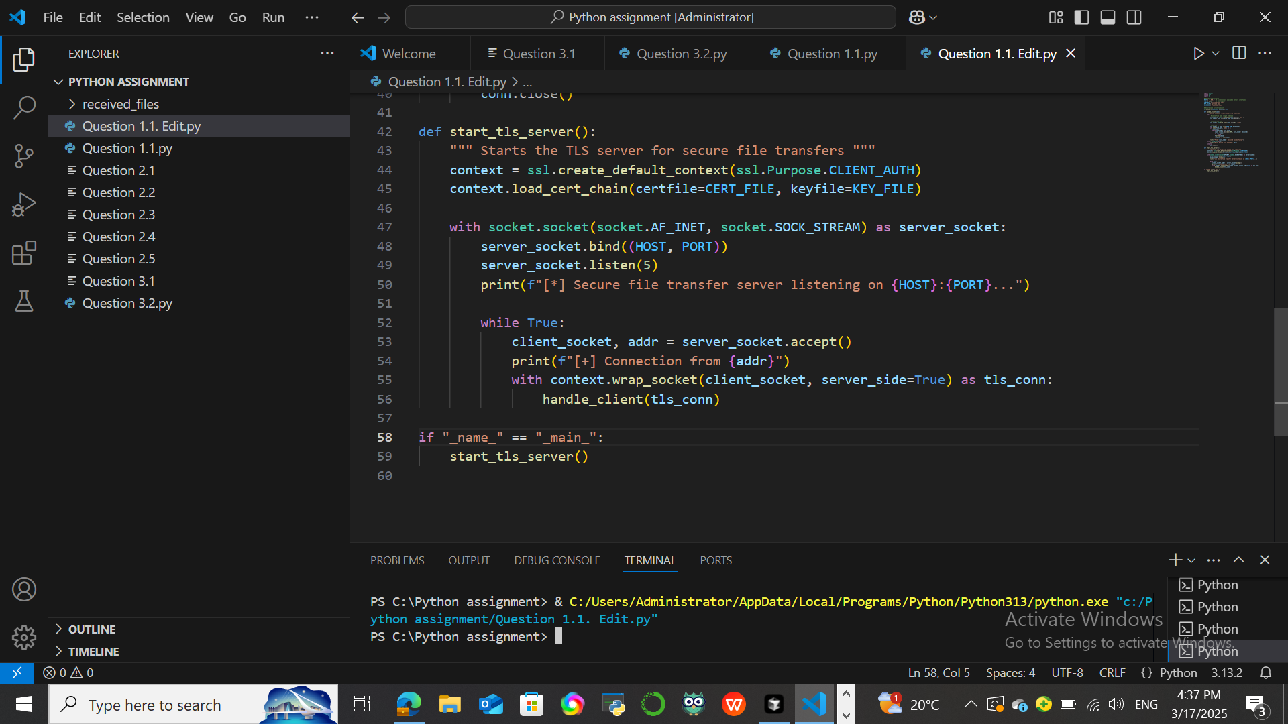
Figure 1 Proof of tls transfer server
(Sean, 2023)

1.2.
import socket
import ssl
import os

SERVER_HOST = "your.server.ip" # Change this to your server's IP
SERVER_PORT = 8443
CERT_FILE = "certificate.pem"

def send_file(file_path):
""" Sends a file securely to the server """
file_name = os.path.basename(file_path)
file_size = os.path.getsize(file_path)

with socket.create_connection((SERVER_HOST, SERVER_PORT)) as sock:
context = ssl.create_default_context(ssl.Purpose.SERVER_AUTH)
context.load_verify_locations(CERT_FILE)
with context.wrap_socket(sock, server_hostname=SERVER_HOST) as tls_sock:
# Send file name length and file name
tls_sock.send(len(file_name).to_bytes(2, 'big'))
tls_sock.send(file_name.encode())

# Send file size
tls_sock.send(file_size.to_bytes(8, 'big'))

# Send file data
with open(file_path, 'rb') as f:
while chunk := f.read(4096):
tls_sock.send(chunk)

print(f"File '{file_name}' sent successfully.")

if "_name_" == "_main_":
send_file("example.txt") # Change to the file you want to send

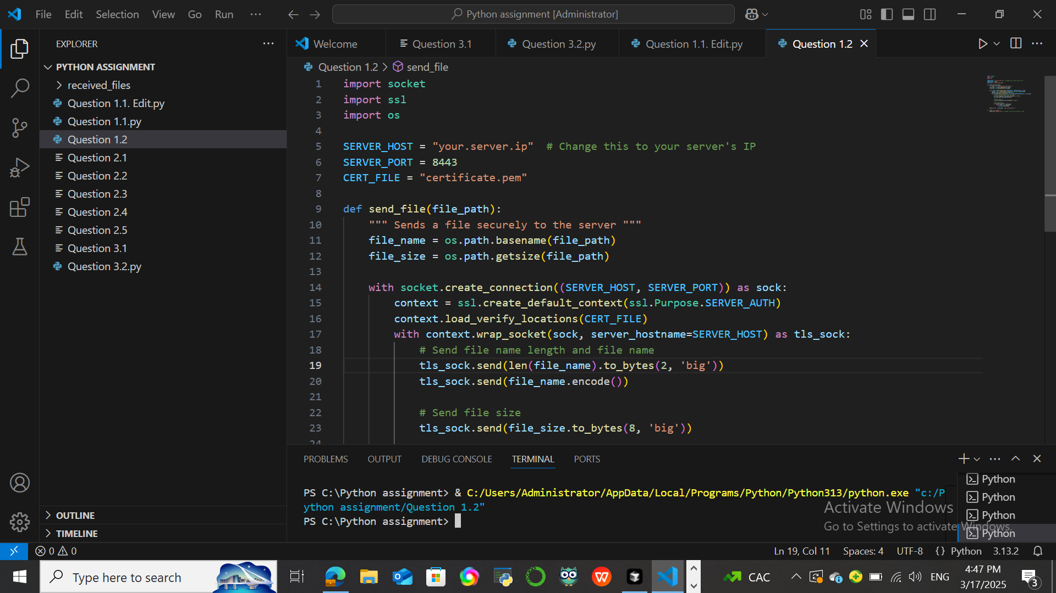
Figure 2 Proof of Client implementation

1.3. TLS encrypts the data to guarantee that the file content is private and uninvited parties cannot intercept it. It uses a hard-to-crack cryptographic algorithm that makes sure that no one other than the web server and web client can read or modify transmitted data. TLS guarantees that the data delivered and received are the same, preventing tampering. In order to prevent man-in-the-middle (MITM) attacks, TLS uses certificates to authenticate the client and server. TLS assists financial institutions in meeting regulatory standards for secure communication when handling sensitive data.
(Ubah, 2022)

1.4.
import socket
import ssl
import os

# Server configuration
HOST = '0.0.0.0'
PORT = 8443
SERVER_CERT = "server.crt"
SERVER_KEY = "server.key"
CA_CERT = "ca.crt"
SAVE_DIR = "received_files"

# Ensure save directory exists
os.makedirs(SAVE_DIR, exist_ok=True)

def handle_client(conn):
"""Handles incoming file transfer from the client."""
try:
# Receive file name length and name
file_name_len = int.from_bytes(conn.recv(2), 'big')
file_name = conn.recv(file_name_len).decode()

# Receive file size
file_size = int.from_bytes(conn.recv(8), 'big')

# Save file
file_path = os.path.join(SAVE_DIR, file_name)
with open(file_path, 'wb') as f:
received = 0
while received < file_size:
chunk = conn.recv(min(4096, file_size - received))
if not chunk:
break
f.write(chunk)
received += len(chunk)

print(f"File '{file_name}' received successfully.")
except Exception as e:
print(f"Error during file transfer: {e}")
finally:
conn.close()

def start_tls_server():
"""Starts the TLS server with mutual authentication."""
context = ssl.create_default_context(ssl.Purpose.CLIENT_AUTH)
context.load_cert_chain(certfile=SERVER_CERT, keyfile=SERVER_KEY)
context.load_verify_locations(CA_CERT)
context.verify_mode = ssl.CERT_REQUIRED # Enforce client authentication

with socket.socket(socket.AF_INET, socket.SOCK_STREAM) as server_socket:
server_socket.bind((HOST, PORT))
server_socket.listen(5)
print(f"[*] Secure file transfer server with mTLS listening on {HOST}:{PORT}...")

while True:
client_socket, addr = server_socket.accept()
print(f"[+] Connection from {addr}")

try:
with context.wrap_socket(client_socket, server_side=True) as tls_conn:
print(f"[✓] Client authenticated: {tls_conn.getpeercert()}")
handle_client(tls_conn)
except ssl.SSLError as e:
print(f"[X] SSL Error: {e}")

if "_name_" == "_main_":
start_tls_server()

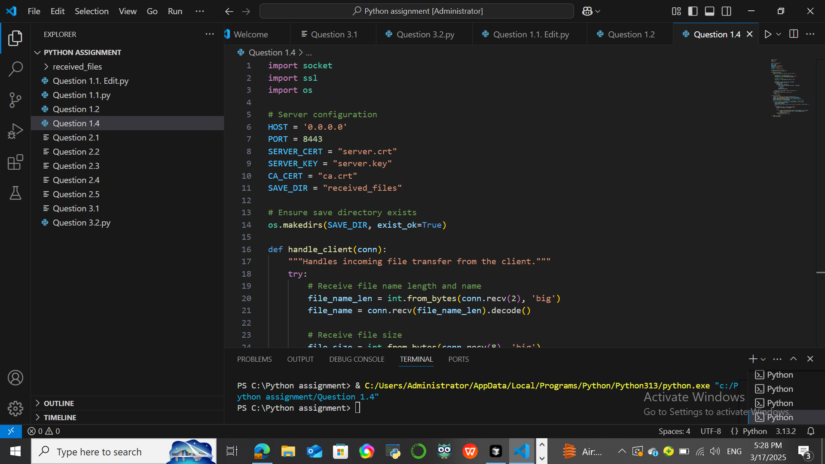
Figure 3 Server that requires mutual authentication

Question 2

2.1.
import asyncio
import dns.resolver
import time

# List of DNS servers to query
dns_servers = [
"1.1.1.1", # Cloudflare DNS
"8.8.8.8", # Google DNS
"9.9.9.9", # Quad9 DNS
"208.67.222.222" # OpenDNS
]

domain = "example.com" # Replace with the domain you want to query

async def query_dns(server, domain):
resolver = dns.resolver.Resolver()
resolver.nameservers = [server]
start_time = time.time()
try:
answer = resolver.resolve(domain)
response_time = time.time() - start_time
return server, response_time, answer
except Exception as e:
return server, float('inf'), None

async def main():
tasks = [query_dns(server, domain) for server in dns_servers]
responses = await asyncio.gather(*tasks)

# Choose the fastest response
fastest = min(responses, key=lambda x: x[1])

if fastest[2]:
print(f"Resolved IP: {ip}")
else:
print("No successful response received.")

# Run the script
asyncio.run(main())

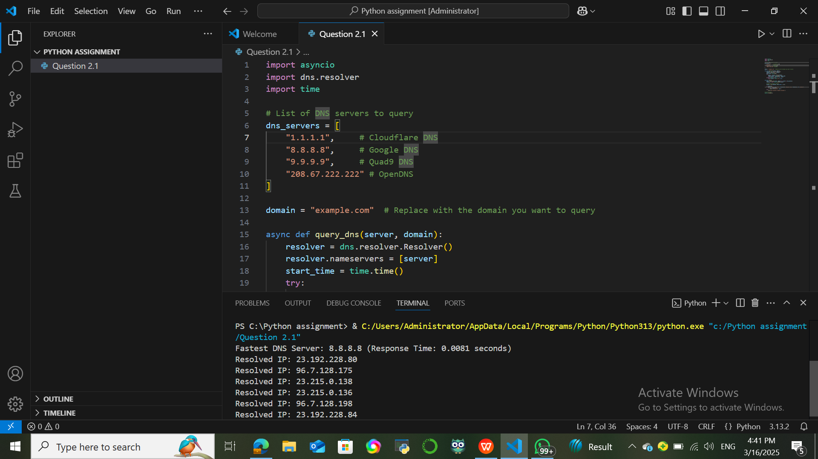
Figure 4 Fastest DNS Server

(Mosh, 2025)

2.2.
import dns.resolver
import dns.dnssec
import dns.name

def resolve_dnssec(domain):
try:
resolver = dns.resolver.Resolver()
#Use Cloudflare DNS
resolver.nameservers = ["1.1.1.1"]
#Set maximum query duration to 30 seconds
resolver.lifetime = 30
#Set indinidual query timeout to 10 seconds
resolver.timeout = 10
# Query A record
response = resolver.resolve(domain, "A")

dnssec_response = resolver.resolve(domain, "DNSKEY")

if dnssec_response:
print(f"DNSSEC verified for {domain}. Resolved IPs:")
for ip in response:
print(ip)
else:
print(f"DNSSEC validation failed for {domain}. Possible security risk!")

except Exception as e:
print(f"DNS resolution error: {e}")

# Test with a DNSSEC-enabled domain
resolve_dnssec("cloudflare.com")

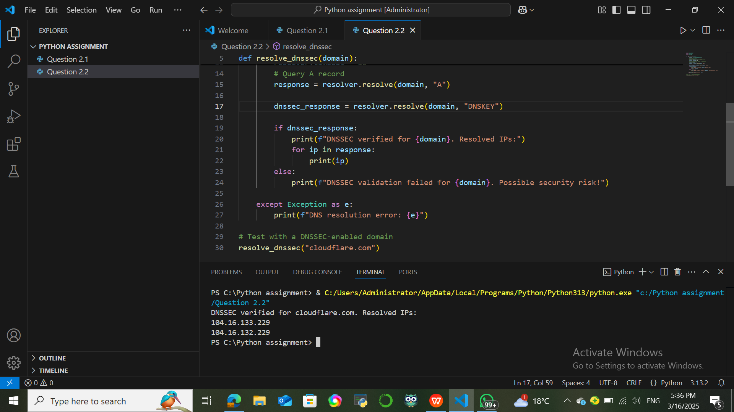
Figure 5 Dns resolution system

2.3.
import dns.resolver
import itertools

# List of DNS servers
dns_servers = itertools.cycle([
"8.8.8.8", "1.1.1.1", "9.9.9.9", "208.67.222.222"
])

def resolve_with_load_balancing(domain):
server = next(dns_servers)
# Get the next DNS server in round-robin order
resolver = dns.resolver.Resolver()
resolver.nameservers = [server]

try:
response = resolver.resolve(domain, "A")
print(f"Queried {server} -> Resolved IPs for {domain}:")
for ip in response:
print(ip)
except Exception as e:
print(f"Error querying {server}: {e}")

# Test resolution
resolve_with_load_balancing("example.com")
resolve_with_load_balancing("cloudflare.com")

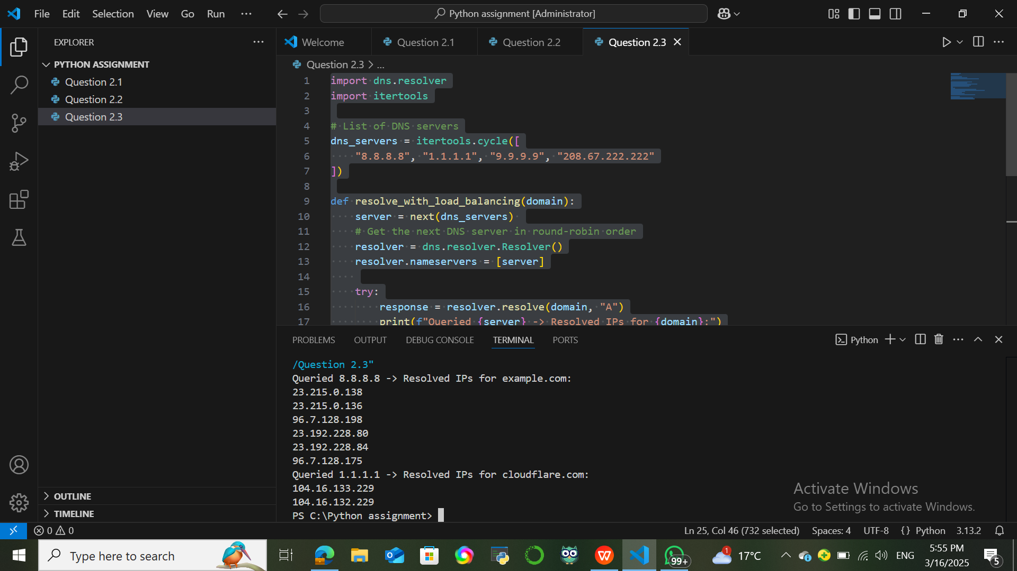
Figure 6 load-balancing mechanism

2.4.
import requests

def doh_resolve(domain):
# Cloudflare DoH Server
url = "https://cloudflare-dns.com/dns-query"
headers = {"accept": "application/dns-json"}
# Query A record
params = {"name": domain, "type": "A"}

try:
response = requests.get(url, headers=headers, params=params, timeout=10)
response.raise_for_status()

data = response.json()

if "Answer" in data:
print(f" DNS-over-HTTPS (DoH) Resolution for {domain}:")
for answer in data["Answer"]:
print(f" - {answer['data']}")
else:
print(f" No DNS records found for {domain}.")

except requests.exceptions.Timeout:
print(f" Error: DoH request timed out for {domain}.")
except requests.exceptions.RequestException as e:
print(f" DoH resolution error: {e}")

# Test with a domain
doh_resolve("example.com")

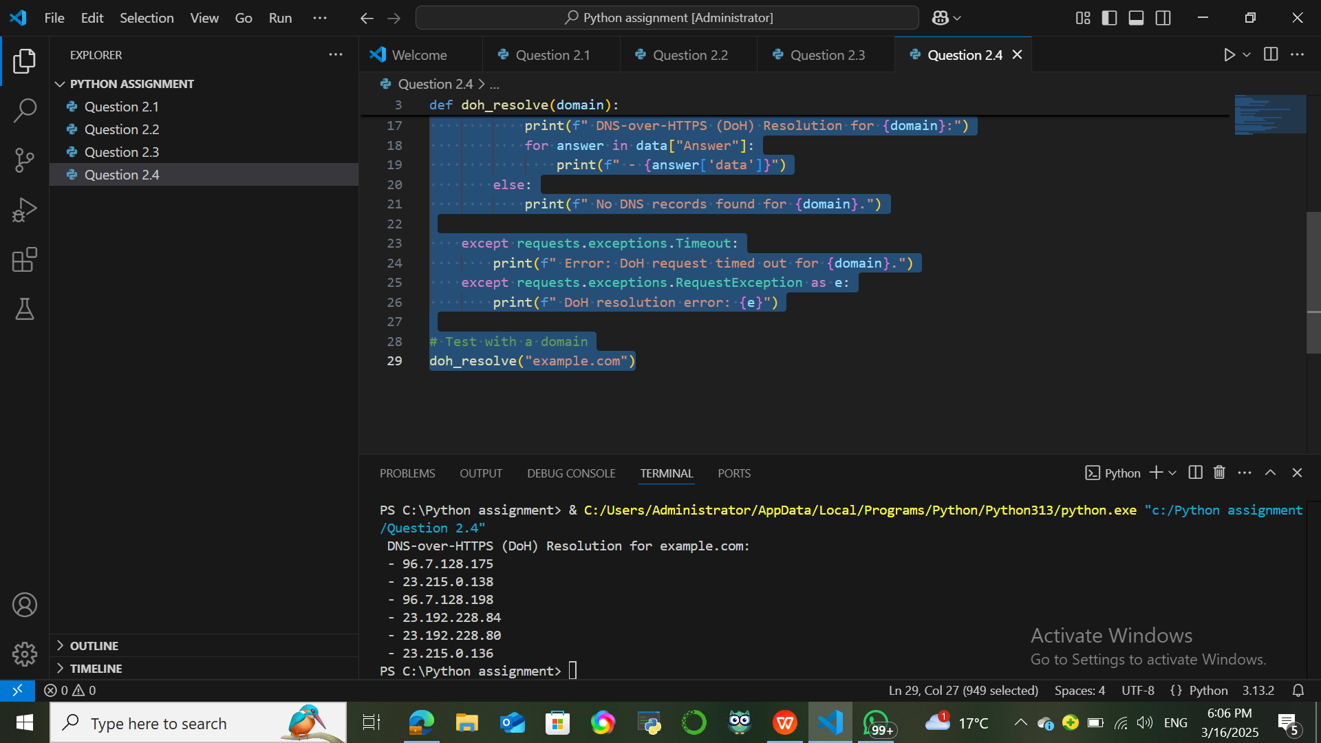
Figure 7 dns-over-https resolution

2.5.
import dns.resolver
import time

# Dictionary to store cached DNS results (with expiration)
dns_cache = {}

# Cache timeout (seconds)
CACHE_EXPIRATION = 60

def resolve_dns(domain):
current_time = time.time()

# Check if the domain is already cached and still valid
if domain in dns_cache:
cached_entry = dns_cache[domain]
if current_time - cached_entry["timestamp"] < CACHE_EXPIRATION:
print(f" Using Cached Result for {domain}: {cached_entry['ip']}")
return cached_entry["ip"]
else:
print(f" Cache Expired for {domain}, re-querying...")

try:
resolver = dns.resolver.Resolver()
# Use Google's DNS
resolver.nameservers = ["8.8.8.8"]
# Query A record
answer = resolver.resolve(domain, "A")

# Get the first IP from the answer
ip_address = answer[0].to_text()

# Cache the result with a timestamp
dns_cache[domain] = {"ip": ip_address, "timestamp": current_time}

print(f" Fetched from DNS Server: {domain} -> {ip_address}")
return ip_address

except dns.resolver.NoAnswer:
print(f" No DNS records found for {domain}.")
except dns.resolver.NXDOMAIN:
print(f" Error: Domain {domain} does not exist.")
except dns.resolver.Timeout:
print(f" Error: DNS query for {domain} timed out.")
except Exception as e:
print(f" DNS resolution error: {e}")

# Example Usage
resolve_dns("example.com")
time.sleep(2) # Simulate some delay
resolve_dns("example.com")

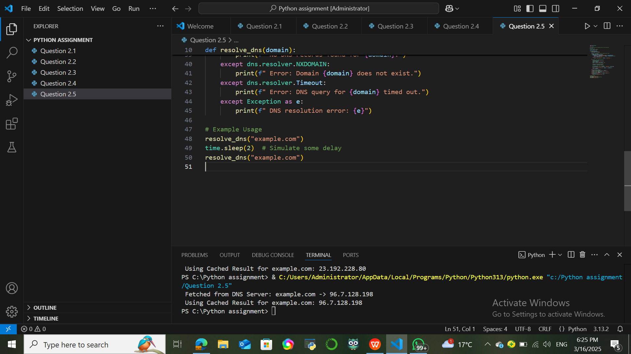
Figure 8 dns query caching
(Insider, 2025)

Question 3

3.1.
import socket
import threading
import os

# Define the host and port
HOST = '127.0.0.1' # Localhost
PORT = 12345 # Port to bind the server to

# Function to handle client communication
def handle_client(client_socket, client_address):
print(f"New connection from {client_address}")

try:
# Receiving the command from the client (either 'send' or 'request')
command = client_socket.recv(1024).decode('utf-8')

if command == 'send':
# Receive file name
file_name = client_socket.recv(1024).decode('utf-8')
file_path = os.path.join('received_files', file_name)

# Create directory to store received files
if not os.path.exists('received_files'):
os.mkdir('received_files')

# Open the file to write the data received
with open(file_path, 'wb') as f:
print(f"Receiving file: {file_name}")
while True:
data = client_socket.recv(1024)
if not data:
break
f.write(data)
print(f"File {file_name} received and saved.")

elif command == 'request':
# Receive the requested file name
file_name = client_socket.recv(1024).decode('utf-8')
file_path = os.path.join('received_files', file_name)

if os.path.exists(file_path):
# Send the file to the client
with open(file_path, 'rb') as f:
print(f"Sending file: {file_name}")
while chunk := f.read(1024):
client_socket.send(chunk)
print(f"File {file_name} sent.")
else:
print(f"File {file_name} not found.")
client_socket.send(b'File not found.')

else:
client_socket.send(b'Invalid command.')

except Exception as e:
print(f"Error with client {client_address}: {e}")

finally:
client_socket.close()

# Function to start the server
def start_server():
# Create a TCP/IP socket
server_socket = socket.socket(socket.AF_INET, socket.SOCK_STREAM)
server_socket.bind((HOST, PORT))
server_socket.listen(5)

print(f"Server started on {HOST}:{PORT}")

while True:
# Accept new connections
client_socket, client_address = server_socket.accept()

# Start a new thread to handle the client
client_thread = threading.Thread(target=handle_client, args=(client_socket, client_address))
client_thread.start()

# Run the server
if "_name_" == "_main_":
start_server()

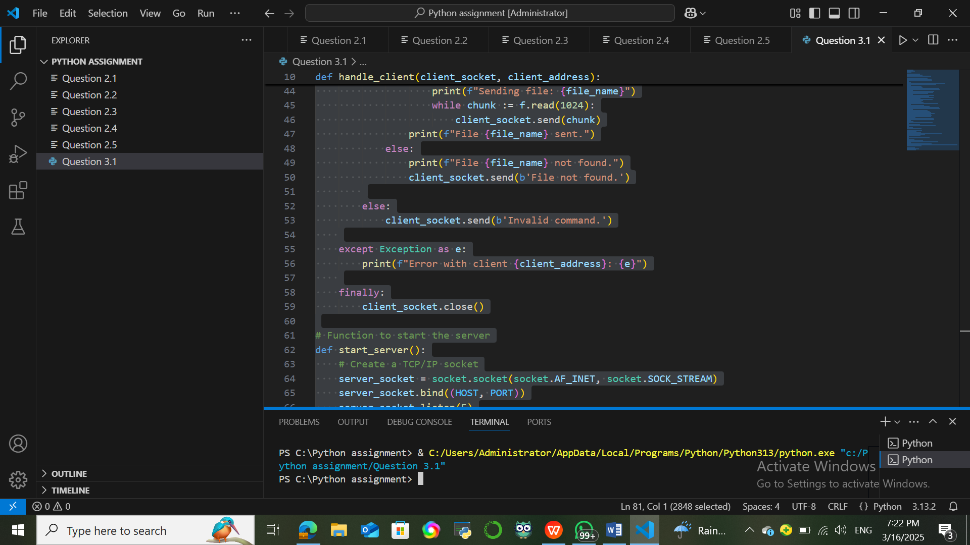
Figure 9 Tcp server using multithreading
(Editor, 2024)

3.2.
import socket
import os

# Define the server address and port
SERVER_HOST = '127.0.0.1' # Server address (localhost)
SERVER_PORT = 12345 # Server port

# Function to upload a file to the server
def upload_file(file_path):
try:
# Check if the file exists
if not os.path.isfile(file_path):
print(f"File '{file_path}' does not exist.")
return

# Connect to the server
with socket.socket(socket.AF_INET, socket.SOCK_STREAM) as client_socket:
client_socket.connect((SERVER_HOST, SERVER_PORT))

# Send 'send' command to notify the server we are sending a file
client_socket.send(b'send')

# Send the file name
file_name = os.path.basename(file_path)
client_socket.send(file_name.encode('utf-8'))

# Send the file content in chunks
with open(file_path, 'rb') as file:
while chunk := file.read(1024):
client_socket.send(chunk)

print(f"File '{file_name}' uploaded successfully.")

except Exception as e:
print(f"An error occurred while uploading the file: {e}")

# Function to request a file from the server
def request_file(file_name):
try:
# Connect to the server
with socket.socket(socket.AF_INET, socket.SOCK_STREAM) as client_socket:
client_socket.connect((SERVER_HOST, SERVER_PORT))

# Send 'request' command to notify the server we want to request a file
client_socket.send(b'request')

# Send the file name to request
client_socket.send(file_name.encode('utf-8'))

# Receive the file from the server and save it
with open(f'received_{file_name}', 'wb') as file:
while chunk := client_socket.recv(1024):
if chunk == b'File not found.':
print(f"File '{file_name}' not found on the server.")
return
file.write(chunk)

print(f"File '{file_name}' downloaded successfully.")

except Exception as e:
print(f"An error occurred while requesting the file: {e}")

# Main function for user interaction
def main():
while True:
print("\nOptions:")
print("1. Upload a file to the server")
print("2. Request a file from the server")
print("3. Exit")

choice = input("Enter your choice (1/2/3): ").strip()

if choice == '1':
file_path = input("Enter the file path to upload: ").strip()
upload_file(file_path)
elif choice == '2':
file_name = input("Enter the file name to request: ").strip()
request_file(file_name)
elif choice == '3':
print("Exiting...")
break
else:
print("Invalid choice. Please try again.")

# Run the client
if "_name_" == "_main_":
main()

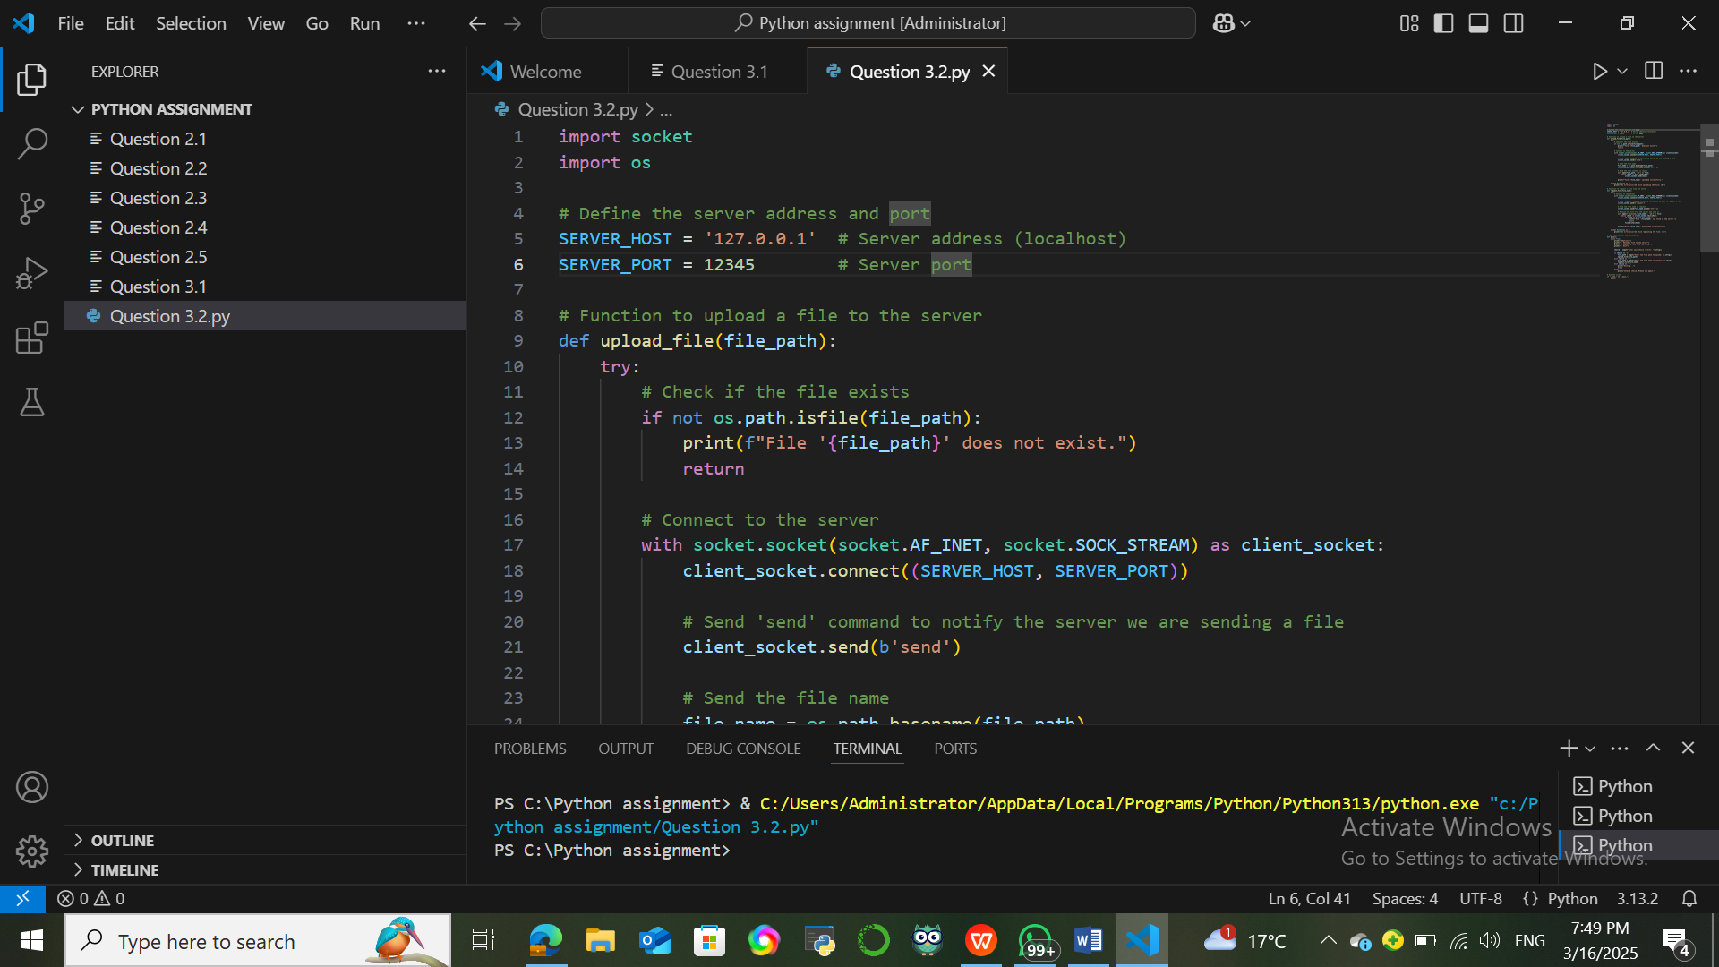
Figure 10 tcp client
(Labs, 2024)

Question 4

4.1.
import socket

# Server Configuration
SERVER_IP = "0.0.0.0"
SERVER_PORT = 12345
BUFFER_SIZE = 1024

# Create a UDP socket
server_socket = socket.socket(socket.AF_INET, socket.SOCK_DGRAM)
server_socket.bind((SERVER_IP, SERVER_PORT))

print(f"UDP Chat Server started on {SERVER_IP}:{SERVER_PORT}")

clients = set() # Store client addresses

while True:
message, client_address = server_socket.recvfrom(BUFFER_SIZE)

if client_address not in clients:
clients.add(client_address)

print(f"Received message from {client_address}: {message.decode()}")

# Broadcast the message to all connected clients
for client in clients:
if client != client_address: # Don't send message back to sender
server_socket.sendto(message, client)

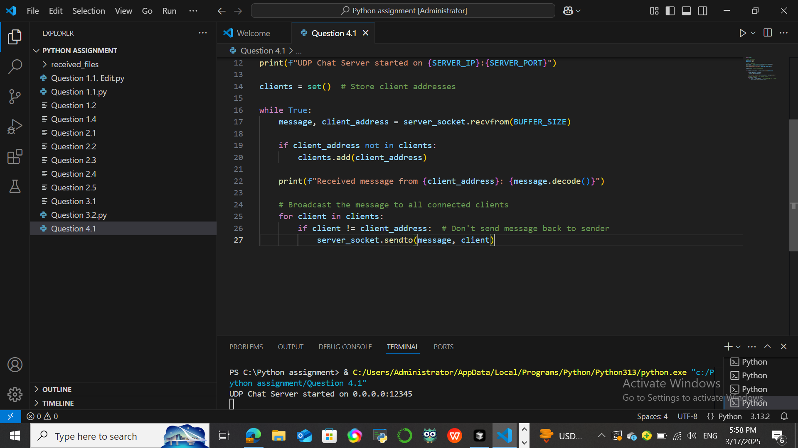
Figure 11 UDP Server
(Alsop, 2024)

4.2.
import socket
import threading

# Server Configuration
SERVER_IP = "127.0.0.1"
SERVER_PORT = 12345
BUFFER_SIZE = 1024

# Create a UDP socket
client_socket = socket.socket(socket.AF_INET, socket.SOCK_DGRAM)

# Function to receive messages from the server
def receive_messages():
while True:
try:
message, _ = client_socket.recvfrom(BUFFER_SIZE)
print("\n" + message.decode() + "\n> ", end="")
except:
break

# Start a thread for receiving messages
threading.Thread(target=receive_messages, daemon=True).start()

# Send messages to the server
while True:
message = input("> ")
if message.lower() == "exit":
break
client_socket.sendto(message.encode(), (SERVER_IP, SERVER_PORT))

client_socket.close()

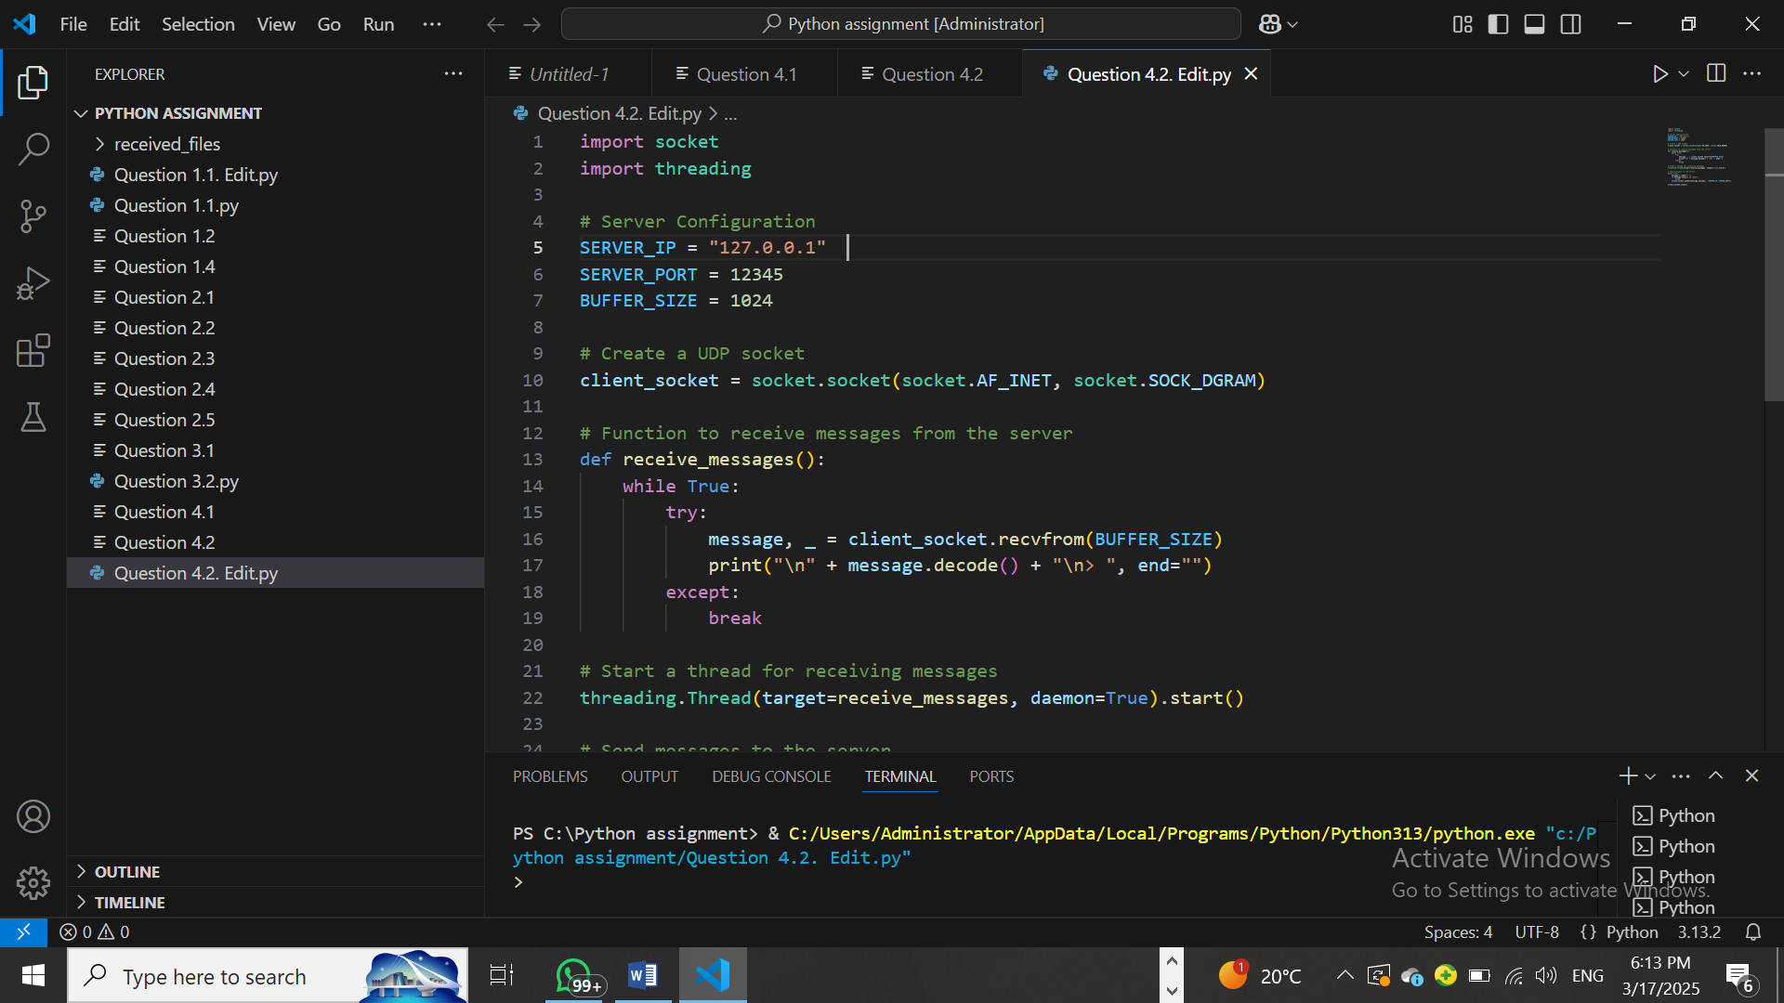
Figure 12 Dns client

Works Cited

Alsop, R. (2024, June 24). Information Security Stack Exchange. Retrieved from Securing HTTP File Transfer: https://security.stackexchange.com
Editor, G. (2024, December 27). GeeksforGeeks. Retrieved from https://www.geeksforgeeks.org
Insider, P. (2025, March 12). Python.org. Retrieved from https://www.python.org
Labs, P. (2024, October 25). Programiz. Retrieved from Python File Operation : https://www.programiz.com
Mosh. (2025, February 12). Programming with Mosh. Retrieved from Youtube: https://m.youtube.com/watch?v=K5KVEU3aaeQ&t=614s&pp=2AHmBJACAQ%3D%3D
Sean. (2023, July 23). Debugbar. Retrieved from How to implement TLS/SSL in python?: https://www.debugbar.com
Ubah, K. (2022, October 16). Implementing TLS/SSL in Python. Retrieved from https://snyk.io

